  Jerusalem Office  Tel.: +972-2-532 83 98  Fax: +972-2-581 96 65  Email: info@fespal.org Web: www.fespal.org |  |   POBox: 25047 Jerusalem  Tel: 02-2976555  Fax: 02-2976557  Email: poll@jmcc.org  Website: www.jmcc.org

Poll No. 82 October 2014

Poll No. 82
October/2014

Public Opinion poll conducted by the Jerusalem Media and Communications Center
After the war: limited retreat in trust in Fatah, increased trust in Hamas
After a small setback in his popularity: President Abbas is still the most trusted personality
Majority supports leadership going to the UN
Majority: Salaries of Gaza government civil servants is responsibility of the National Consensus Government
‘ISIS’ harms the Palestinian cause
Minority supports US mediation in negotiations

A public opinion poll conducted by the Jerusalem Media and Communications Center (JMCC) between 15th and 19th of October 2014 showed that the war achieved the interests of the Palestinian people and increased support for armed struggle and Hamas. It decreased support for negotiations and for Fatah. The majority of those polled, 53.4%, said the war achieved the Palestinian people’s interests, while 21.8% said it harmed their interests. Meanwhile, the percentage of those who support military operations against Israeli targets increased from 31.5% before the war in April, 2014 to 42.7% after the war in October, 2014. The war seems to have caused an increase in the popularity of Hamas at the expense of Fatah. The percentage of trust in Hamas increased from 16.8% in April, 2014, before the war, to 25.7% in October 2014, after the war.

It is apparent from the poll results that the war resulted in a slight setback in the majority percentage which supports a resumption of negotiations, from 54.7% in April, 2014 before the war, to 52.4% in October of this year.

Trust in Fatah also dropped from 41.7% before the war to 35.1% after the war, even though President Abbas retained his position as the most trusted Palestinian personality. Still, the level of trust dropped from 25.2% in April, 2014 before the war, to 23.3% in October of the same year. In contrast, the level of trust in Ismail Haniyeh rose from 13.5% before the war to 17.9% after the war.

The PA and Gaza government salaries
The poll also showed that the major part of the Palestinian public, 43.2% believes the responsibility for providing salaries for government employees in the Gaza Strip is the responsibility of the National Consensus Government as opposed to 21.1% who considered it to be Hamas’ responsibility and 28.9% who said it was the responsibility of donor countries.

Furthermore, 42.2% of those polled said they believed Hamas handled relief assistance during the war well, as opposed to 37.3% who said the contrary. It is noteworthy that the majority who said they did not believe the assistance was handled well, 53.6% are from Gaza, as opposed to 27.6% from the West Bank.
In general, there was no mentionable change on the majority percentage, 68.1%, who support the perpetuation of the PA, and the 26.8% who support the PA’s dissolution in the current stage.

Who is the winning side in Gaza?
The majority, 57.1%, considered Hamas to be the winning side in the recent war as opposed to 8.0% who said Israel was the winning side. It should be mentioned that this constitutes a setback in the percentage who said Hamas was the winning side after the 2012 war, which was 70.6% at the time. It is also noticeable that 64.1% of those who consider Hamas to be the winning side are from the West Bank, while 45.3% are from the Gaza Strip.

Meanwhile, almost half, 49.8% of those polled, held Israel responsible for the suffering of Gaza’s people while 15.9% said their suffering lies with Hamas. It is noteworthy that 12.5% of those who considered the people’s suffering to be the responsibility of Hamas are from the West Bank while 21.6% are from the Gaza Strip.

The war and diplomacy
At the level of political and diplomatic moves, the majority, 64.8% considered the Palestinian leadership’s move towards to the UN as a good step that serves Palestinian national interests, while 27.7% said the step would not make any difference. As for the Gaza Reconstruction Conference, the majority of those polled, 51.2% said they expected the donor countries to honor their commitments as opposed to 38.9% who said they did not expect them to honor them.

Furthermore, it seems a clear majority of 72.2% of those polled said they were satisfied with the level of solidarity in the West Bank with Gaza during the war, as opposed to 26.8% who said they were dissatisfied with the level of solidarity. This constitutes a retreat in West Bank solidarity after the last war in 2012 when the level of satisfaction was 85.1% and the level of dissatisfaction was only 13.8%.

As to whether it was possible for the Palestinians or the Israelis to have avoided the war, the majority of those polled, 79% said it would not have been possible to avoid it because Israel planned to launch the war in all cases. Contrastingly, 17.7% said the Palestinians could have avoided the war. It is worth noting that most of those who believe the Palestinians could have avoided the war are in Gaza, double those in the West Bank.

As for which party would be the best mediator in any future negotiations, the majority of those polled, 23.8% said the UN would be the best mediator, while 21% of respondents said the EU; 20.2% said Egypt, while 15.6% said the Middle East Quartet. Only 6% said the United States.

Islamic State in Iraq and Syria (ISIS)
As for the Palestinian people’s position towards ISIS, the majority, 70.8%, responded negatively to the news that ISIS had advanced in Iraq and Syria, as opposed to 7.6% who had a positive response to it.
Regarding expectations from ISIS towards the Palestinian cause, 5.2% said they believed ISIS serves the Palestinian cause, while 45.4% said that ISIS harms the cause; 34.8% said it had no impact on the Palestinian cause.

Methodology:

A random sample of 1200 people over the age of 18 was interviewed face-to-face throughout the West Bank and Gaza Strip between 15 and 19 of October 2014. The interviews were conducted in randomly selected homes, and the subjects inside each home were also selected randomly according to Kish tables. The interviews were conducted in 130 sampling points chosen randomly according to population.

In the West Bank 750 people were surveyed from the following areas:
Hebron: Hebron, Bani Na’im, Yatta, Halhul, Al-Shyoukh, Tarqoumia, Idhna, Qalqas, Khursa, Al-Fawwar refugee camp.Jenin: Jenin, Ya’bad, Arraba, Al-Yamun, Faqqu’a, A-lMughayyir, Al-Tayba, Jenin refugee camp.Tubas: Tubas, Tayaseer. Ramallah & al-Bireh: Sinjel, Der Dibwan, Ni’lin, Beituniya, Al-Mazra’ah al-Sharqiya, Kafr ‘Ein, Al-Tira, Surda, Qibya, Al-Am’ari refugee camp. Jericho: Jericho, Al-Jiftlek. Jerusalem : Abu Dis, Al-‘Ezariyeh, Hizma, Jaba’, Beit Hanina, Shu’fat, Old City, Al-Issawiyeh, Ras al-Amoud, Qalandia refugee camp. Bethlehem:Al- Khader, Bethlehem, Tuqu’, Beit Fajjar, Battir, Ayda refugee camp. Nablus:, Jamama’in, Asira al-Shamaliyeh, Azmut, Nablus ,Burqa, Burin, Urif, Al-Sawyeh, Ein Beit il Ma’ refugee camp. Salfit : Al-Zawyeh, Deir Istiya. Tulkarem: Deir al Ghusun, Tulkarem, Bal’a, Nazlet ‘Isa, Kafr al Labad. Qalqilya: Qalqiliya, Jayyous.
.
In the Gaza Strip 450 people were surveyed from the following ares:
Gaza: al-Rimal a-Shamali, a-Rimal a-Janoubi, a-Zeitoun, a-Shuja’ia, a-Tufah, a-Daraj, a-Naser, a-Sheikh Radwan,a-sheikh Ajleen, Tal al-Hawa, al-Mughraga, Shati Refugee Camp . Khan Younis: Khan Younis, Absan al-Kabira, Abasan al-Saghira, Bani Suheila, al-Qarara, Khuza’, Khan Younis Refugee Camp. Rafah: Rafah, Shouket a-Soufi, Rafah Refugee Camp. Gaza North: Jabalia, Beit Lahia, Beit Hanoun, Jabalia Refugee Camp. Deir al-Balah: Deir al-Balah, Burij, -Zawaydeh, Nussirat, al-Maghazi Refugee Camp, Bureij Refugee Camp, Deir al-Balah Refugee Camp.

The margin of error is ±3 percent, with a confidence level of 95%.

Sample Distribution |  | Occupation of Respondents
52.5% of the respondents were from the West Bank,10.0 % from Jerusalem,  37.5% from the Gaza Strip.  15.8% said they live in villages,8.8 % in refugee camps, and 75.4% in towns/cities.  50.5% were male, 49.5% were female.  69.5% were married, 25.3%, single,  4.0% widowed 1.1% divorced, 0.1% no answer.  The average age of the respondents was 36.5  years. |  | - Students 12.9%  - Laborers 11.3%  - Housewives 35.1%  - Farmers/fishermen 2.2%  - Craftsmen 0.7%  - Businessmen/private business 8.2%  - Public Sector Employees 13.1%  - Private Sector Employees 5.9%  - Professionals (e.g. doctors/lawyers/ pharmacists/engineers) 1.0%  - Unemployed 7.8%  - Retired 1.8%,  - No answer 0.0%.

Results:
Q1. To what extent do you feel optimistic or pessimistic regarding the future in general? Would you say that you are very optimistic, optimistic, pessimistic, or very pessimistic?

 | Total | West Bank | Gaza
 | n= 1200 | n= 750 | n=450
Optimistic | 64.4 | 64.8 | 63.6
Pessimistic | 35.3 | 34.9 | 36
Very pessimistic
No answer | 0.3 | 0.3 | 0.4

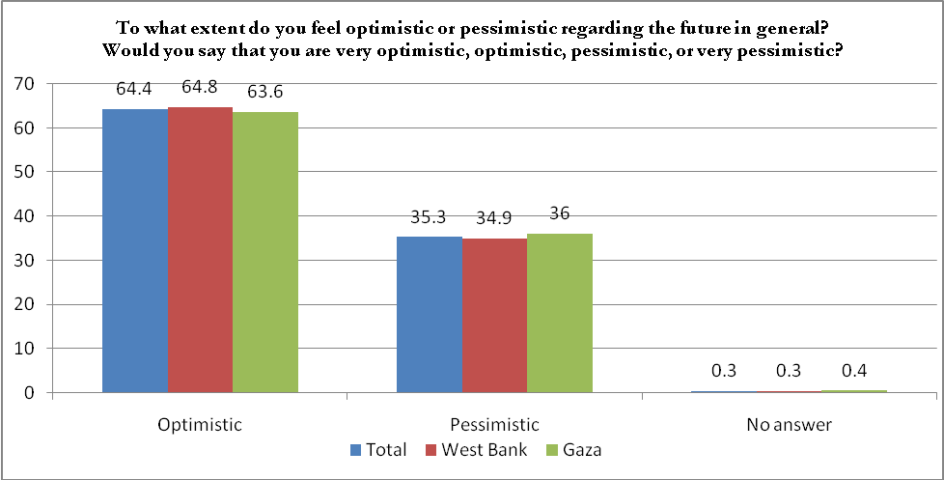

Q2. In general, what is the best method to achieve the Palestinian people’s goals of ending the occupation and establishing a state?
 | Total | West Bank | Gaza
 | n= 1200 | n= 750 | n=450
Peaceful negotiations | 35.9 | 33.2 | 40.4
Armed resistance (armed Intifada) | 31.7 | 32.8 | 29.8
Non-violent resistance (peaceful Popular Intifada) | 25.2 | 26.8 | 22.4
Other | 2.8 | 1.1 | 5.6
I don’t know \ no answer | 4.4 | 6.1 | 1.8

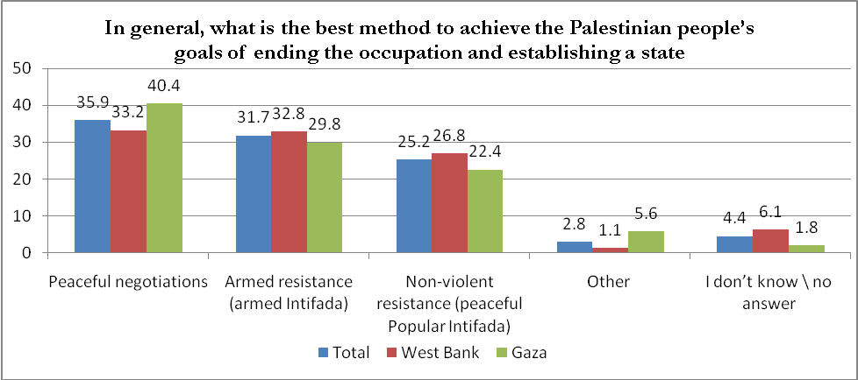

Q3. There is a debate on the future of the PNA whereby some people believe that dissolving the PNA is necessary now while others believe that the perpetuation of the PNA and maintaining it is a necessity. What do you think?

 | Total | West Bank | Gaza
 | n= 1200 | n= 750 | n=450
Dissolving the PNA is necessary | 26.8 | 31.1 | 19.6
Perpetuating and maintaining the PNA is a necessity | 68.1 | 63.2 | 76.2
I don’t know \ no answer | 5.1 | 5.7 | 4.2
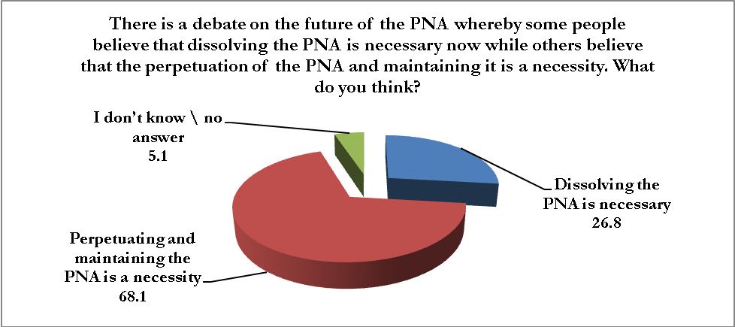
Q4. Do you strongly agree, somewhat agree, somewhat disagree, strongly disagree with peace negotiations between the Palestinians and the Israelis?
 | Total | West Bank | Gaza
 | n= 1200 | n= 750 | n=450
Agree | 52.4 | 56.7 | 45.1
Disagree | 44.6 | 39.2 | 53.5
I don’t know \ no answer | 3.0 | 4.1 | 1.4

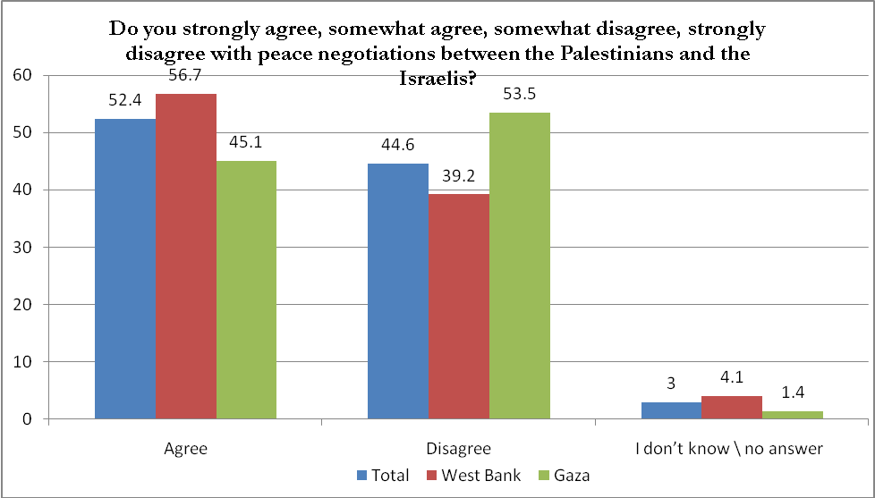

Q5. If negotiations between Israel and the Palestinians were to be resumed, who would you prefer to act as mediator between the two sides?
 | Total | West Bank | Gaza
 | n= 1200 | n= 750 | n=450
The United Nations | 23.8 | 21.9 | 26.9
The European Union | 21.0 | 19.3 | 23.8
Egypt | 20.2 | 21.1 | 18.7
The Mideast Quartet | 15.6 | 16.0 | 14.9
The United States | 6.0 | 4.7 | 8.2
I don’t know \ no answer | 13.4 | 17.0 | 7.5
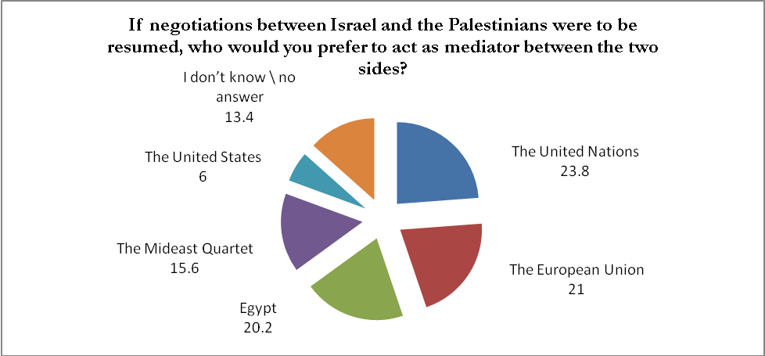

Q6. Now that the Gaza war has ended, who do you think is the winning side? Israel, Hamas, Israel and Hamas or neither Israel nor Hamas?
 | Total | West Bank | Gaza
 | n= 1200 | n= 750 | n=450
Israel | 8.0 | 4.8 | 13.3
Hamas | 57.1 | 64.1 | 45.3
Israel and Hamas | 2.5 | 2.7 | 2.2
Neither Israel nor Hamas | 30.7 | 26.4 | 37.8
I don’t know \ no answer | 1.7 | 2.0 | 1.4
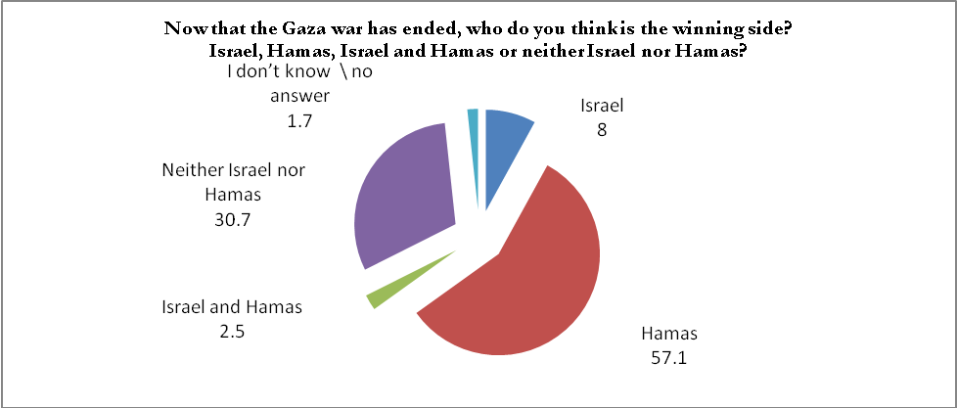

Q7. Hamas accuses Israel of targeting the civilians in this war while Israel accuses Hamas of hiding among the civilians, what do you think?
 | Total | West Bank | Gaza
 | n= 1200 | n= 750 | n=450
Hamas was hiding among the civilians | 3.2 | 2.9 | 3.6
Israel was targeting the civilians | 77.6 | 81.5 | 71.1
Hamas was hiding among the civilians and Israel targeted the civilians | 17.4 | 13.1 | 24.7
I don’t know \ no answer | 1.8 | 2.5 | 0.6
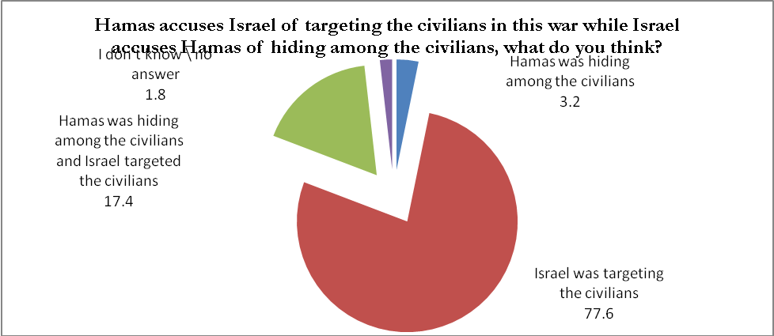

Q8. Now that the Gaza war has ended, do you believe that it was possible for the Palestinian side to avoid it, or was Israel planning to launch the war in all cases?
 | Total | West Bank | Gaza
 | n= 1200 | n= 750 | n=450
Palestinians could have avoided it | 17.7 | 13.1 | 25.3
Israel planned to launch the war in all cases | 79.0 | 83.2 | 72.0
I don’t know \ no answer | 3.3 | 3.7 | 2.7
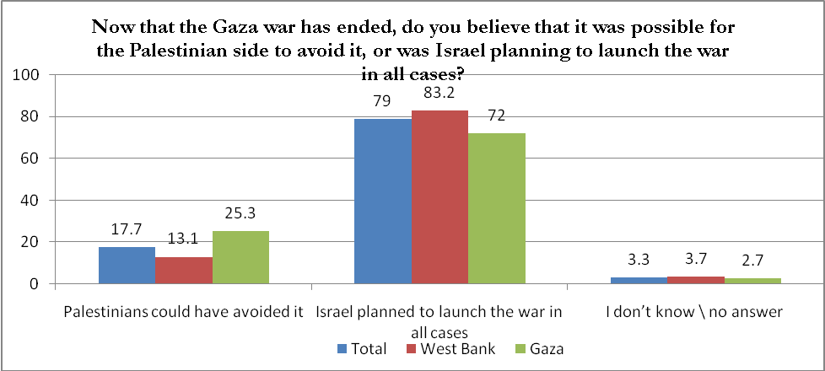

Q9. To what extent are you satisfied with West Bank solidarity with the Gaza Strip during the war?
 | Total | West Bank | Gaza
 | n= 1200 | n= 750 | n=450
Satisfied | 72.2 | 74.1 | 69.1
Dissatisfied | 26.8 | 24.4 | 30.7
I don’t know \ no answer | 1.0 | 1.5 | 0.2

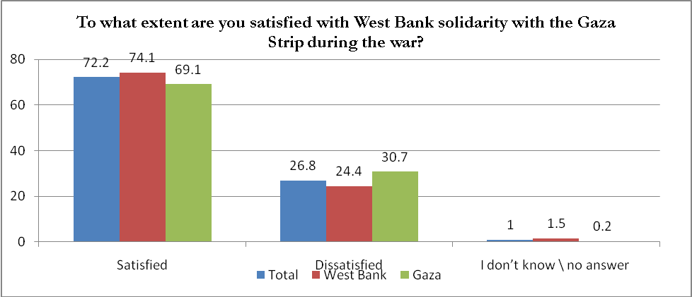

Q10. Do you think that the locally-made rockets fired from Gaza strip towards Israeli regions help,harm,or don’t make any difference with regards to the Palestinian goals?
 | Total | West Bank | Gaza
 | n= 1200 | n= 750 | n=450
Help | 61.8 | 64.5 | 57.1
Harm | 14.8 | 9.6 | 23.6
Don’t make any difference | 20.3 | 21.2 | 18.7
I don’t know \ no answer | 3.1 | 4.7 | 0.6

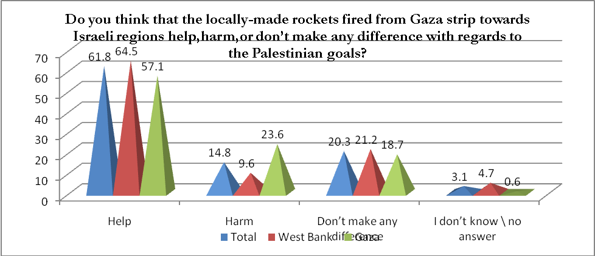

Q11. Do you support the continuation of military operations against Israeli targets as an appropriate response under current political conditions or do you oppose them and believe they harm Palestinian national interests?
 | Total | West Bank | Gaza
 | n= 1200 | n= 750 | n=450
An appropriate response under current political conditions | 42.7 | 46.3 | 36.7
Oppose them and believe they harm Palestinian national interests | 50.4 | 43.2 | 62.4
Others | 0.3 | 0.4 | 0.7
I don’t know \ no answer | 6.6 | 10.1 | 0.2

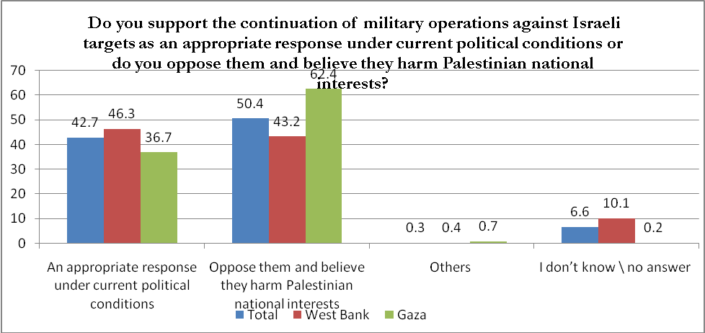

Q12. The Palestinian leadership has recently ceased its participation in bilateral negotiations with Israel and it has turned to the UN. To what extent are you satisfied with this matter? Would you say that you are: satisfied, neither satisfied nor dissatisfied, or you are dissatisfied?
 | Total | West Bank | Gaza
 | n= 1200 | n= 750 | n=450
Satisfied | 54.4 | 50.0 | 61.8
Neither satisfied nor dissatisfied | 30.7 | 31.9 | 28.7
Dissatisfied | 10.9 | 12.4 | 8.4
I don’t know \ no answer | 4.0 | 5.7 | 1.1

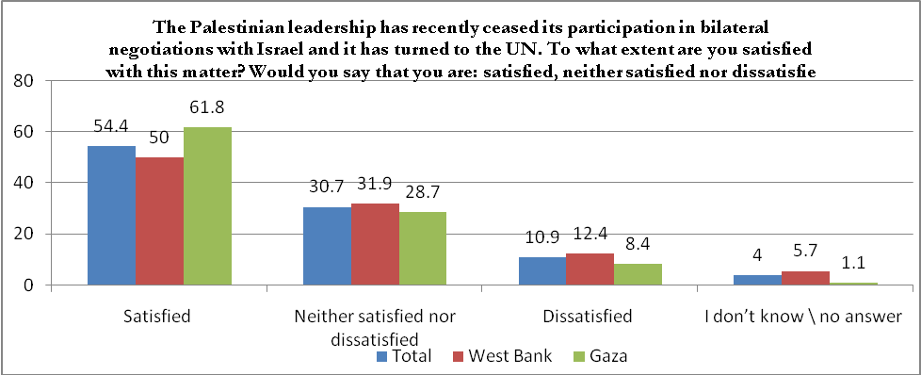

Q13. What is the impact of the Palestinian leadership’s approach to the UN on you stance towards Fatah Movement. Is the impact positive, negative, or neither positive nor negative?
 | Total | West Bank | Gaza
 | n= 1200 | n=750 | n= 450
Positive impact | 47.9 | 43.6 | 55.1
Negative impact | 8.0 | 9.1 | 6.2
Neither positive nor negative | 40.3 | 42.0 | 37.3
I don’t know \ no answer | 3.8 | 5.3 | 1.4
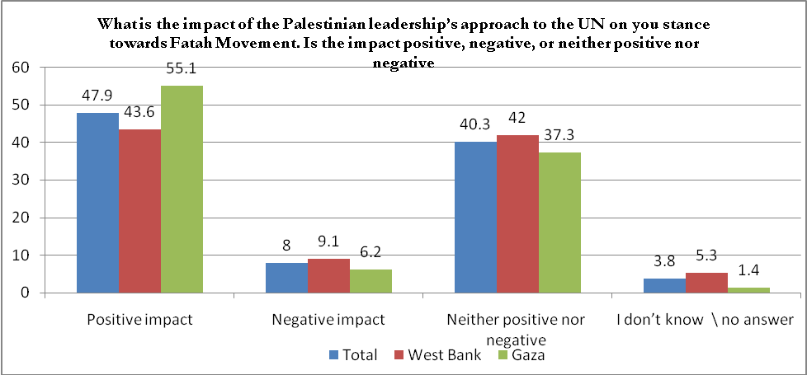

Q14- If PLC elections were held today, which of the following parties would you vote for?
 | Total | West Bank | Gaza
 | n=1200 | n= 750 | n= 450
Hamas | 29.0 | 28.9 | 29.1
Fatah | 37.3 | 34.8 | 41.6
Other parties | 10.3 | 9.5 | 11.8
I won’t vote | 19.1 | 21.3 | 15.3
No answer | 4.3 | 5.5 | 2.2

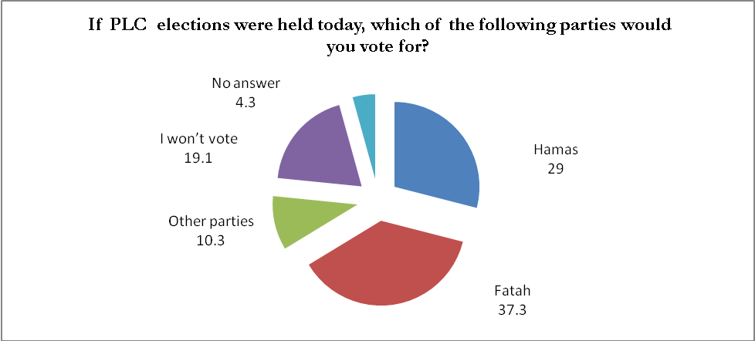
Q15- If presidential elections were held today, with Ismael Haniyeha and Mahmoud Abbas (Abu Mazen) as the only candidates running the elections, for which one of them would you vote?
 | Total | West Bank | Gaza
 | n=1200 | n= 750 | n=450
Mahmoud Abass (Abu Mazen) | 37.3 | 34.1 | 42.4
Ismail Haniyeh | 30.1 | 28.7 | 32.4
I don’t know \ no answer | 32.6 | 37.2 | 25.2

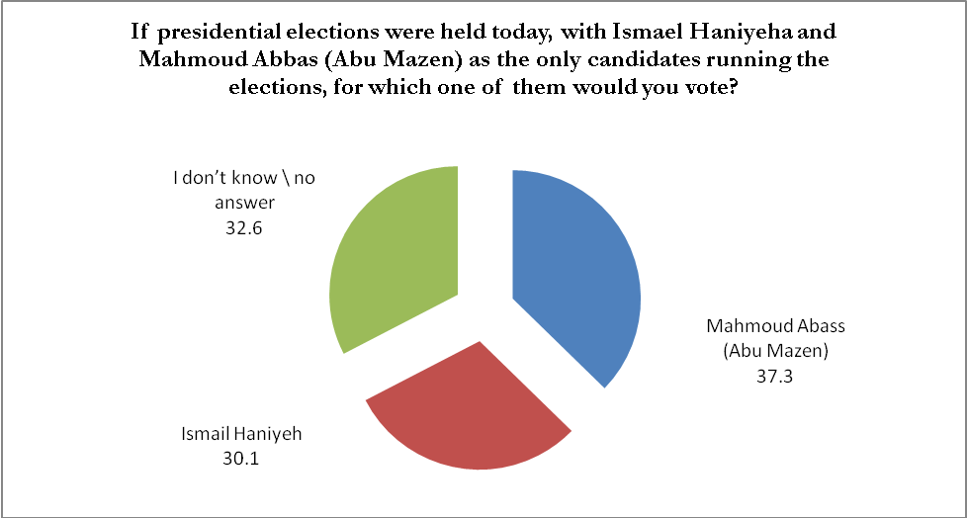

Q16- Do you believe the recent war on Gaza over the last few weeks has achieved the Palestinian people’s interest, harmed the Palestinian people’s interest, or did not affect the Palestinian people’s interest?
 | Total | West Bank | Gaza
 | n=1200 | n= 750 | n=450
It achieved the Palestinian people’s interest | 53.4 | 59.2 | 43.8
It harmed the Palestinian people’s interest | 21.8 | 12.7 | 36.9
It did not affect the Palestinian people’s interest | 20.3 | 21.5 | 18.4
I don’t know \ no answer | 4.5 | 6.6 | 0.9

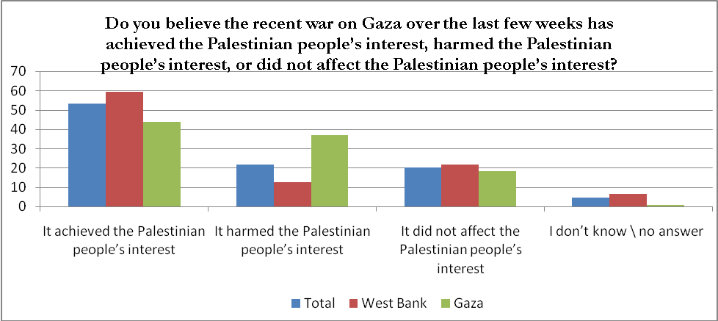
Q17-Do you believe that the war on Gaza over the last few weeks has made it easier or harder for Fatah and Hamas to maintain the reconciliation government or has the war not made any difference?
 | Total | West Bank | Gaza
 | n=1200 | n= 750 | n=450
Made unity easier to maintain | 52.9 | 51.3 | 55.6
Made unity harder to maintain | 17.3 | 17.2 | 17.6
Not made any difference to the reconciliation government | 26.9 | 27.7 | 25.6
I don’t know \ no answer | 2.9 | 3.8 | 1.2

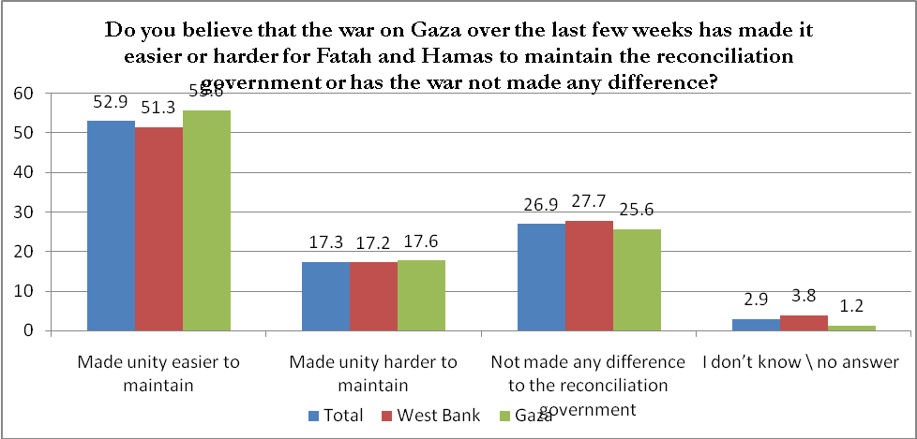

Q18- Do you think the Hamas government in Gaza handled relief assistance during the war well?

 | Total | West Bank | Gaza
 | n=1200 | n= 750 | n=450
Yes | 42.2 | 46.3 | 35.5
No | 37.3 | 27.6 | 53.6
I don’t know \ no answer | 20.5 | 26.1 | 10.9

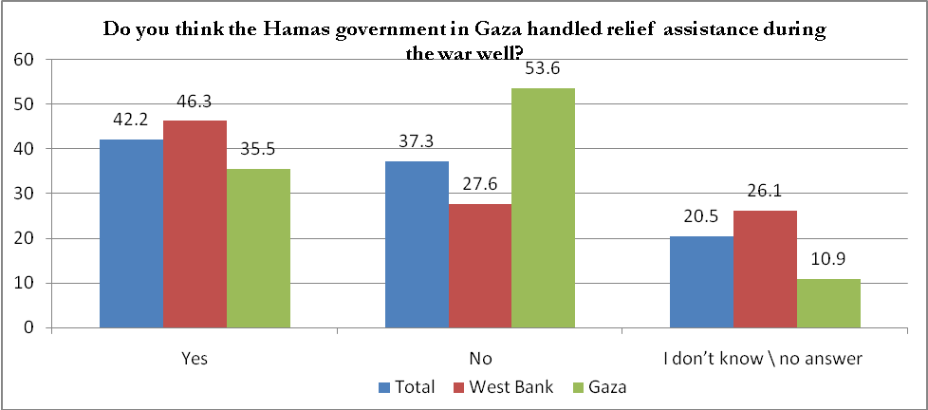

Q19- Do you think the main responsibility for the suffering of Gaza’s people lies more with Israel, Egypt, Hamas or the Palestinian Authority?
 | Total | West Bank | Gaza
 | n=1200 | n= 750 | n=450
Israel | 49.8 | 53.6 | 43.6
Egypt | 14.3 | 13.5 | 15.8
Hamas | 15.9 | 12.5 | 21.6
The PA | 14.2 | 12.1 | 17.6
I don’t know \ no answer | 5.8 | 8.3 | 1.4

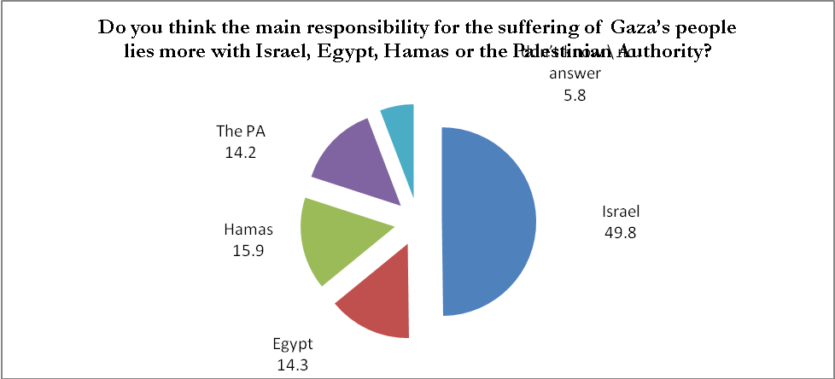

Q20- In your opinion, do you think providing salaries for government employees in the Gaza Strip is more the responsibility of Hamas, the National Consensus Government or the donor countries?
 | Total | West Bank | Gaza
 | n=1200 | n= 750 | n=450
Hamas | 21.1 | 18.1 | 26.0
National Consensus Government | 43.2 | 40.1 | 48.2
Donor countries | 28.9 | 31.3 | 24.9
I don’t know \ no answer | 6.8 | 10.5 | 0.9

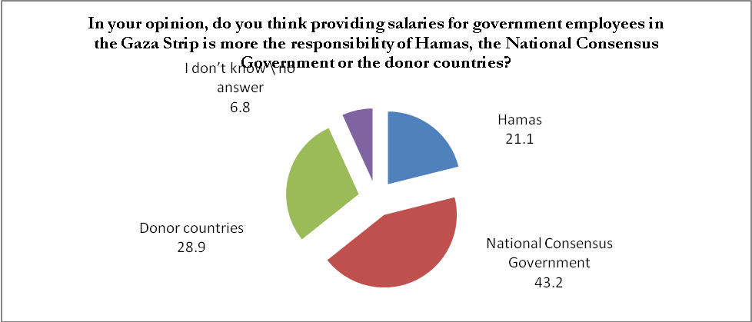
Q21- Lately, there has been news in the media about ISIS forces advancing in Iraq and Syria. What response do you have towards this: very positive, moderately positive, moderately negative or very negative?
 | Total | West Bank | Gaza
 | n=1200 | n= 750 | n=450
Positive | 7.6 | 6.6 | 8.9
Negative | 70.8 | 70.4 | 71.6
No opinion | 13.9 | 14.3 | 13.3
I don’t know \ no answer | 7.7 | 8.7 | 6.2

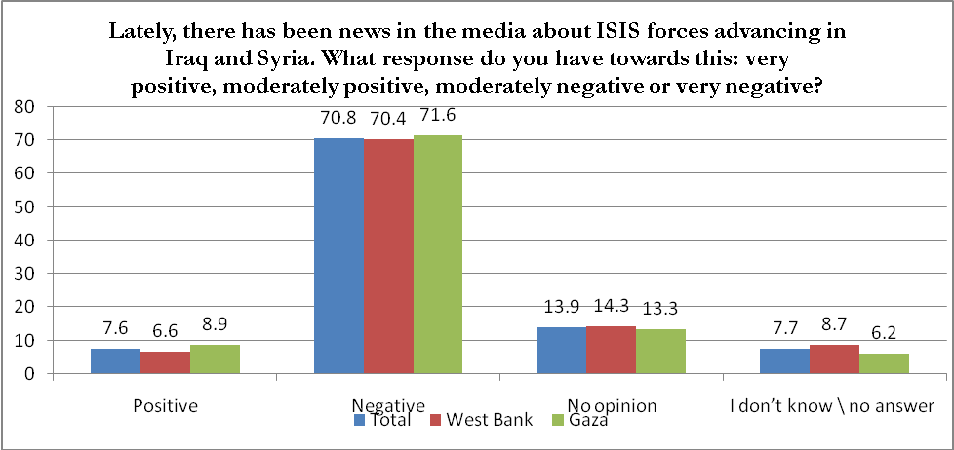

Q22- Do you think ISIS serves the Palestinian cause? Does it harm it? Or does it have no impact on the cause?
 | Total | West Bank | Gaza
 | n=1200 | n= 750 | n=450
It serves the Palestinian cause | 5.2 | 5.3 | 4.9
It harms the Palestinian cause | 45.4 | 43.9 | 48.0
It has no impact on it | 34.8 | 33.2 | 37.6
I don’t know \ no answer | 14.6 | 17.6 | 9.5

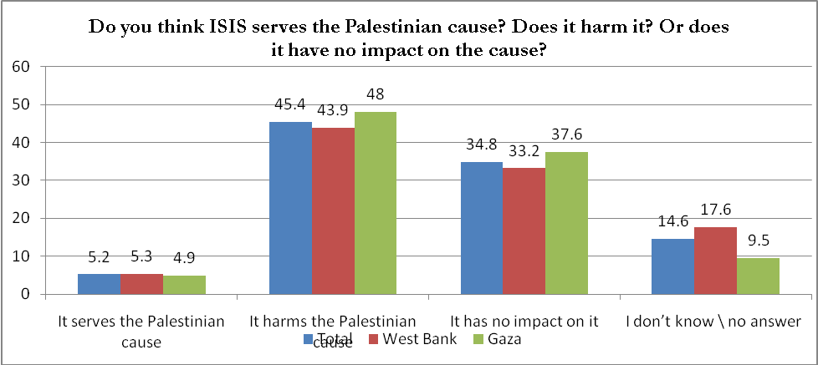

Q23- The Palestinian leadership recently asked the UN to issue a resolution ending the occupation in 3 years. Do you believe this is a good step that serves Palestinian national interests, a bad step that harms Palestinian national interests or a step that won't make any difference?
 | Total | West Bank | Gaza
 | n=1200 | n=750 | n=450
A good step that serves Palestinian national interests | 64.8 | 57.9 | 76.2
A bad step that harms Palestinian national interests | 3.3 | 3.9 | 2.4
The step won’t make any difference | 27.7 | 31.5 | 21.3
I don’t know \ no answer | 4.2 | 6.7 | 0.1

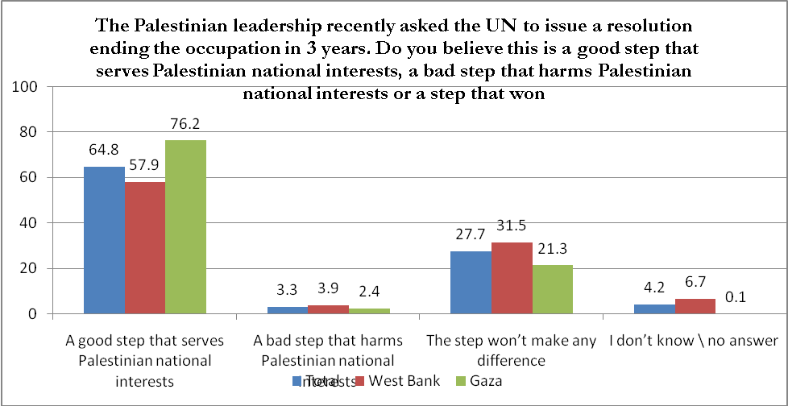

Q24- Donor countries pledged $5.4 billion to the reconstruction of Gaza and to the PA treasury during the recent Gaza Reconstruction Conference in Cairo. Do you expect these donor countries to honor their commitments or not?
 | Total | West Bank | Gaza
 | n=1200 | n= 750 | n=450
I expect the donor countries to honor their commitments | 51.2 | 47.6 | 57.1
I don't expect them to honor their commitments | 38.9 | 40.5 | 36.2
I don’t know \ no answer | 9.9 | 11.9 | 6.7
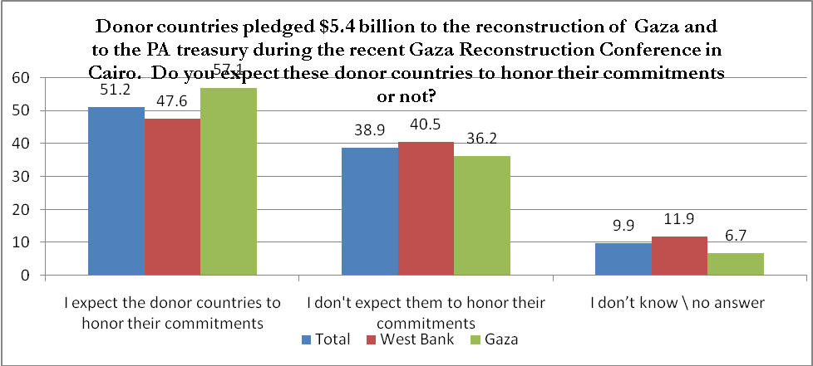

Q25-In general, Is religion an important part of your life?
 | Total | West Bank | Gaza
 | n=1200 | n= 750 | n=450
Yes | 95.2 | 94.8 | 95.8
No | 4.7 | 5.1 | 4.0
No answer | 0.1 | 0.1 | 0.2
Q26- Have you performed Al Umra ( a pilgrimage to Mecca performed by Muslims that can be undertaken at any time of the year)?
 | Total | West Bank | Gaza
 | n=1200 | n= 750 | n=450
Yes | 27.7 | 32.8 | 19.1
No | 72.1 | 67.1 | 80.4
No answer | 0.2 | 0.1 | 0.5

Q27- Do you think that the Palestinian Personal Law must be based on the principles of Islamic Sharia
or on the Civil Law?
 | Total | West Bank | Gaza
 | n=1200 | n= 750 | n=450
The Islamic Sharia | 50.1 | 51.2 | 48.2
The Civil Law | 12.0 | 9.7 | 15.8
Both | 36.0 | 37.7 | 33.1
I don’t know \ no answer | 1.9 | 1.4 | 2.9

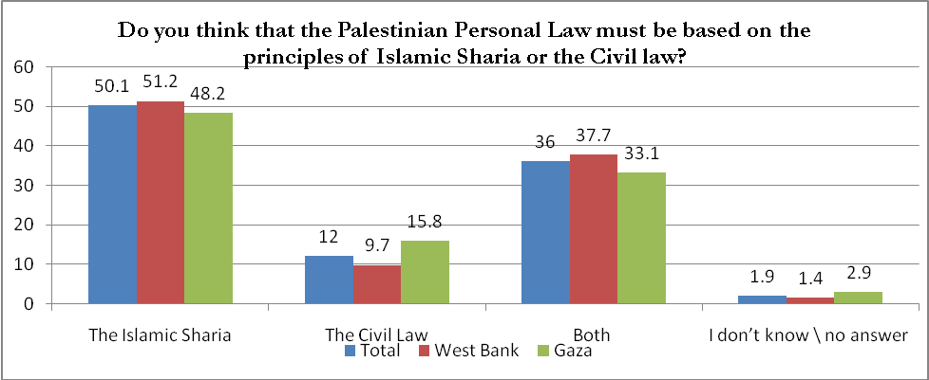

Q28- Did you fast during the month of Ramadan?
 | Total | West Bank | Gaza
 | n=1200 | n= 750 | n=450
Most of the days or all of the days | 94.3 | 93.1 | 96.4
A few days | 3.7 | 4.3 | 2.7
I did not fast | 1.8 | 2.4 | 0.7
No answer | 0.2 | 0.2 | 0.2

Q29- During the month of Ramadan, did you perform all religious prayers?
 | Total | West Bank | Gaza
 | n=1200 | n= 750 | n=450
I prayed all days | 86.2 | 82.9 | 91.6
I prayed only on Fridays | 8.3 | 10.7 | 4.2
I didn’t pray | 5.0 | 5.6 | 4.0
No answer | 0.5 | 0.8 | 0.2

Q30- Do you support marriage of young women under the age of 18?
 | Total | West Bank | Gaza
 | n=1200 | n= 750 | n=450
Yes | 23.4 | 18.8 | 31.1
No | 75.8 | 80.8 | 67.6
I don’t know \ no answer | 0.8 | 0.4 | 1.3

Q31- Do you support having multiple wives?
 | Total | West Bank | Gaza
 | n=1200 | n= 750 | n=450
Yes | 26.9 | 22.8 | 33.8
No | 71.8 | 76.5 | 64.0
I don’t know \ no answer | 1.3 | 0.7 | 2.2

Q32- Which political or religious faction do you trust the most?*
 | Total | West Bank | Gaza
 | n=1200 | n= 750 | n=450
Fatah | 35.1 | 32.3 | 39.8
Hamas | 25.7 | 24.4 | 27.8
Islamic Jihad | 2.2 | 2.5 | 1.6
PFLP | 1.9 | 0.7 | 4.0
Other Islamic Factions | 1.0 | 1.2 | 0.7
Others | 2.6 | 3.1 | 1.8
I don’t trust anyone | 24.8 | 26.1 | 22.4
No answer | 6.7 | 9.7 | 1.9
*This was an open-ended question no options were read to the interviewee

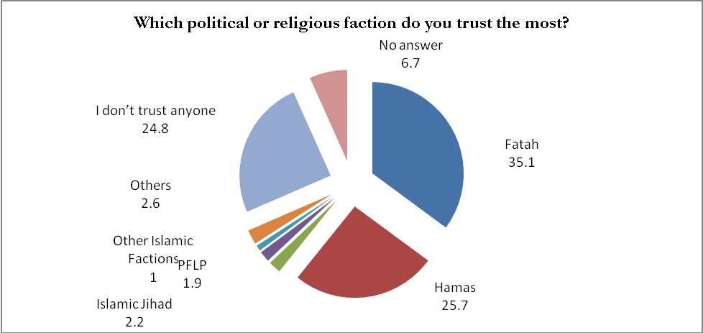

Q33. Which Palestinian personality do you trust the most?*

 | Total | West Bank | Gaza
 | n=1200 | n= 750 | n=450
Mahmoud Abass (Abu Mazen) | 23.3 | 22.3 | 24.9
Isma’el Haniyeh | 17.9 | 16.0 | 21.1
Marwan Barghouthi | 5.7 | 5.6 | 5.8
Khaled Mish’al | 3.8 | 3.9 | 3.6
Others | 14.4 | 11.6 | 19.1
I don’t trust anyone | 27.6 | 29.5 | 24.4
No answer | 7.3 | 11.1 | 1.1
*This was an open-ended question no options were read to the interviewee
